OSPF

OSPF areas are virtual separations of networks. It can be used for managing system where there are too many routes and processes or for security purposes. All routers in the same area needs to have the same area id. Area 0 is the backbone area, because it is automatic created as the first area. Standard areas are areas that summarizes data to the backbone area. Stub areas are areas that only receives a limit information. Standard areas and stub areas need to connect to backbone area.

Stub areas automatically change external routes into default routes. A totally stubby area changes every route from other areas into default routes. A not so stubby route makes external routes pass through it and then appears as external routes. Totally stubby area filters type 3, 4, and 5 LSA. NSSA area filters type 4 and 5 LSA.

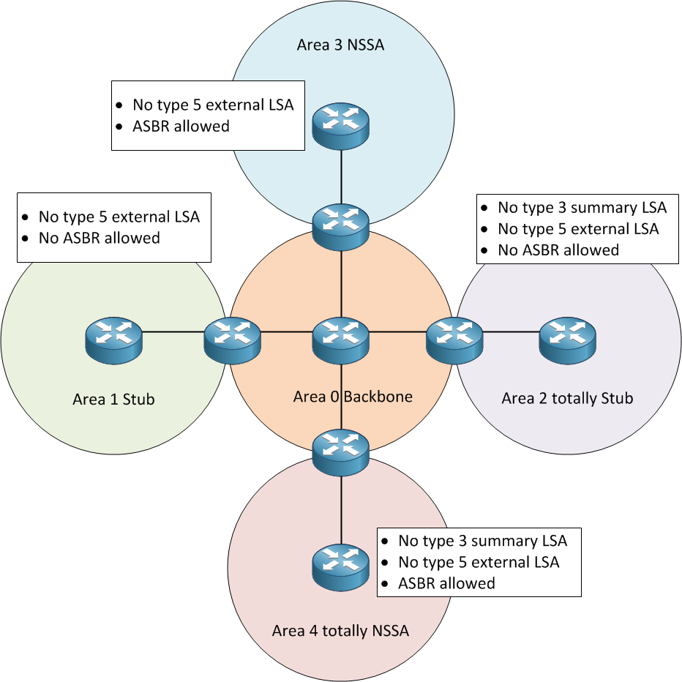

Link state advertisement (LSA) is the way router communicates in OSPF.

LSA 1: Router LSA. Tell other routers to add itself into link state database. The message includes a list of directly connected links of this router. Type 1 LSA message always stays within an area.

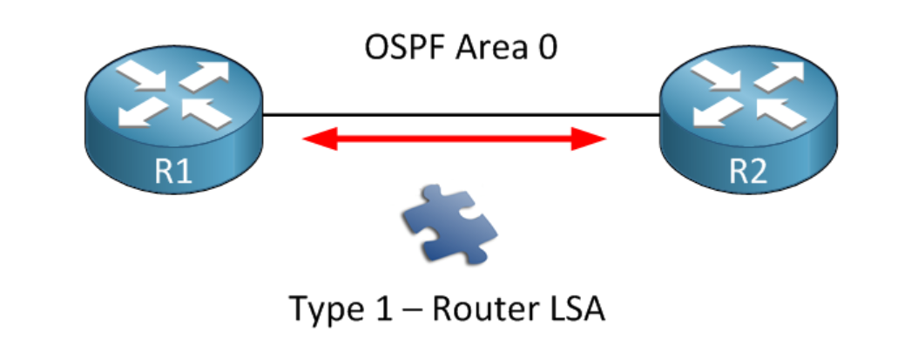

LSA 2: Network LSA. Elect a designate router and tell all other routers. LSA 2 is created for multi-access networks, which are networks that have more than 2 devices in it. LSA 2 messages are generated by DR routers. Type 2 LSA message always stays within an area.

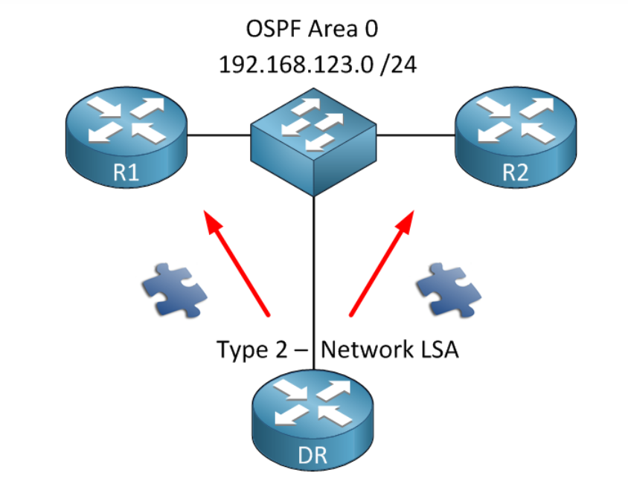

LSA 3: Summary LSA. Summarizes data from networks. For example, if R1 sends a type 1 LSA in Area 2, R2 send a LSA 3 that summarizes area 2’s network information and sends it to Area 0 and Area 51.

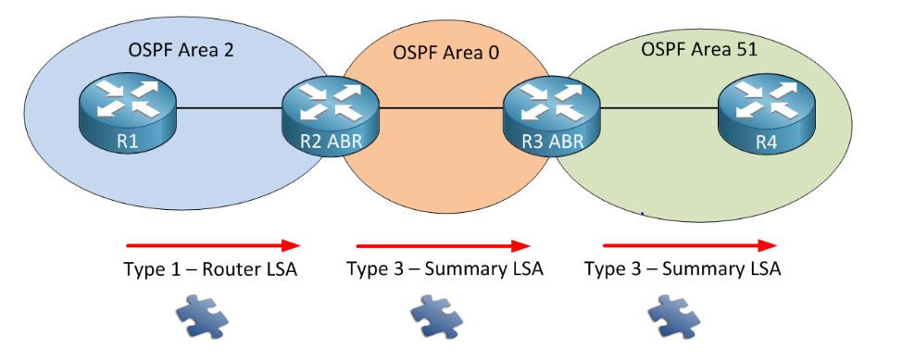

LSA 4: Summary ASBR LSA. Path to ASBR routers. For example, R1 receives information from a RIP router and redistributes it into OSPF. This makes R1 an autonomous system border router (ASBR). When R2 receives LSA from ASBR R1, it changes it into a type 4 LSA and send it to other areas. The LSA 4 contains information about the route to ASBR routers.

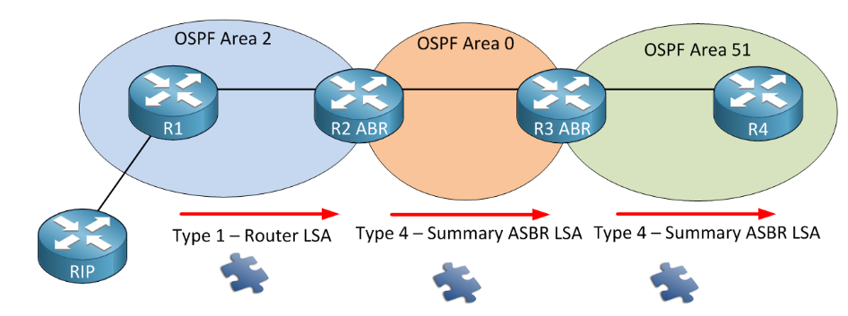

LSA 5: Autonomous system external LSA. Summarizes ASBR router data. For example, R1 will use the prefix (5.5.5.0/24) of RIP router to create a LSA 5 message and send it to all areas.

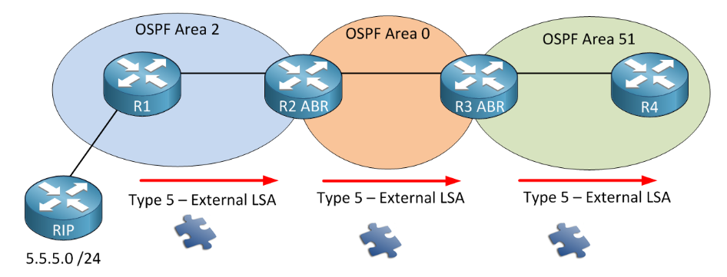

LSA 6: Multicast OSPF LSA. OSPF multicast extension. This LSA is currently not being used and not supported by Cisco.

LSA 7: Not-so-stubby area LSA. Work as a LSA 5 in NSSA area. NSSA areas don’t allow LSA 5. For example, area 2 is a NSSA area, and the information about RIP router is send in LSA 7. Router 2 then translates it into a LSA 5.

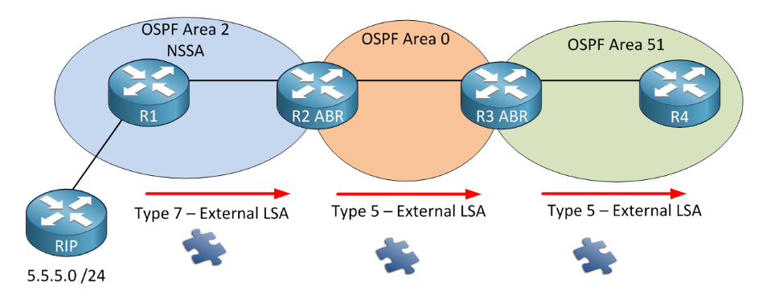

A stub network is a network with no knowledge of other networks. A stub network will send most or all its traffic via a single path. Routers in an OSPF network know other routers and networks. Totally stubby areas are like stub areas that they limit the information they can receive, but totally stubby area is stricter than a stub area that it also restricts a type 3 LSA message. Like a stub area, a totally stubby area optimizes router by reducing the information it can receive. However, a stubby area and a stub area cannot contain ASBR routers. A NSSA area can function like stub area. In addition to stub area, NSSA area can use LSA 7 messages, which replaces LSA 5 messages. A NSSA area should be used when there is a ASBR router in a stub area. A stub area is better than a normal area when there are too many external routes, because stub area turns all external routes into a single default route. One should use a totally stub area instead of stub area when one doesn’t want type 3 LSA in the area. We can identify a stub area when we cannot detect neither type 5 LSA nor type 4 LSA in an area. We can identify a totally stubby area when we cannot detect neither of type3, 4, nor 5 messages. We can identify a NSSA area when we detect a LSA 7 message, because only NSSA area ASBR router sends them.